**题目：**

A. Shuttle Bus

time limit per test

2.0 s

memory limit per test

256 MB

input

standard input

output

standard output

Alex is a driver of a shuttle bus whose working duty is to drive around Byteland and let the tourists do sightseeing there.

The territory of Byteland is strange which can be represent by an grid with exactly 2 rows and *N* columns. There are *M* churches on some cells in Byteland where sightseeing there are forbidden. On the other hand, there is an attraction in each of the remaining cells.

On each day, Alex drives the shuttle bus from the frontier of Byteland, which is the top-left corner of the 2 × *N* grid. The shuttle bus can travel from one cell to its adjacent cells which have a common side with it each time. Alex will drive the shuttle bus to visit all attractions. Undoubtedly, he cannot drive into the cells where the churches are located.

Alex does not want to make his tourists bored, so he hopes to visit all attractions, except the churches, exactly once. The tour can end in any cell. Given the length of the grid and the positions of the churches, determine whether Alex can do so successfully.

**Input**

The first line of contains 2 integers *N*, *M*, representing the length of the grid of Byteland and the number of churches there. (1 ≤ *N* ≤ 109, 1 ≤ *M* ≤ 5000)

The following M lines contains 2 integers *ri*, *ci*, representing the position of the *ith* church. (1 ≤ *ri* ≤ 2, 1 ≤ *ci* ≤ *N*)

The positions of the churches are distinct and no church will be located at the top-left corner of the grid.

**Output**

Please output Yes if Alex can visit all attractions except the churches exactly once and output No otherwise.

**Examples**

**Input**

**Copy**

5 3  
2 1  
1 3  
2 5

**Output**

Yes

**Input**

**Copy**

3 2  
2 1  
2 3

**Output**

No

**Input**

**Copy**

3 2  
1 2  
2 2

**Output**

No

思路：

1.貌似可以用暴力模拟的方法做，但是在排序的时候很难将一坐标（x,y），根据x的大小进行排序。并且在时间上也卡的比较紧，换思路。

2.貌似可以根据两点之间相差的奇偶性进行比较。实现一下试试。

将每一个点的（x，y）的x，y坐标相加，若两相邻位置的差为偶数则不能完成遍历全图。并且若两点的x坐标相等也无法遍历全图。

主要代码：

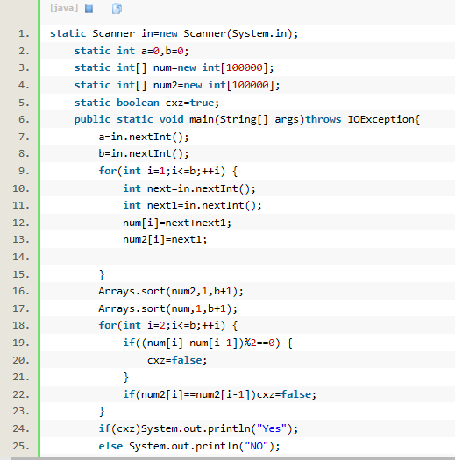

反馈：在第8个测试点错误

3．貌似遗漏了第一个点的比较，若第一个点坐标和为偶数同样无法完成遍历

增加对第一个点的奇偶判定

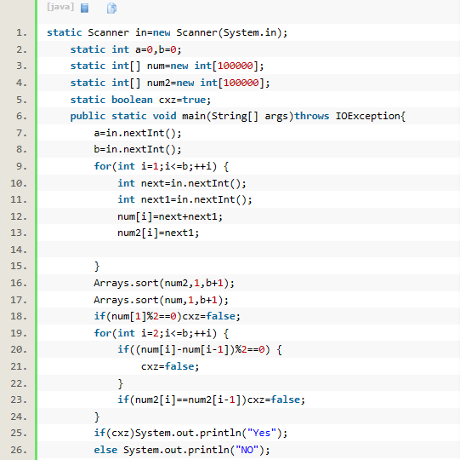

测试点飞快地前进，wrong answer在第89个测试点

4.貌似还有一些情况需要考虑。。。。。

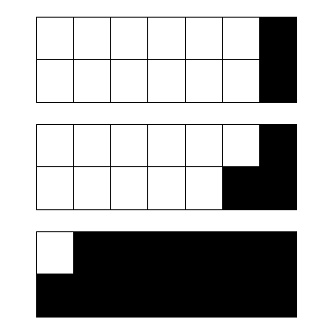

再加一发判断

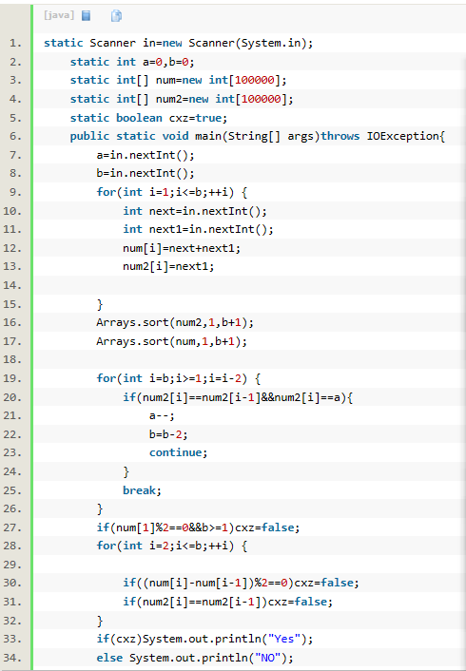

测试点飞快前进

C:\Users\DELL\Documents\Tencent Files\1196140338\Image\Group\Z]D@A6]}3L)5S%]N~Z()~@K.png

成功Ac